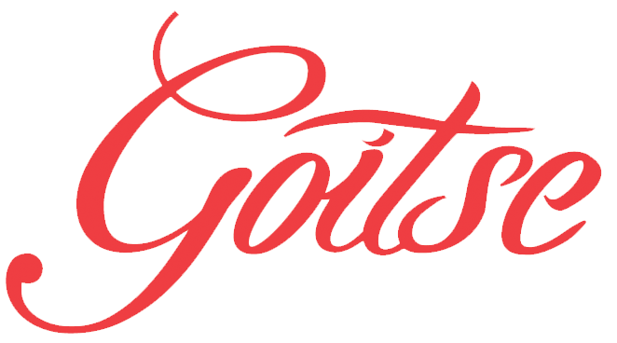

The popular and multi-award-winning quintet Goitse was forged in the white-hot creative crucible of Limerick’s Irish World Academy. Named Live Ireland’s “Traditional Group of the Year”, Chicago Irish American News’ “Group of the Year”, as well as winning the prestigious “Freiburger International Leiter 2016” award in Germany, Goitse have become a leader of the new generation of traditional Irish ensembles.
Goitse has released six critically acclaimed recordings and maintains a year round touring schedule that includes performances throughout Ireland, UK, Germany, France and the United States. Their distinctive sound lies in the quality of their own compositions interspersed with age-old traditional tunes which make each performance unique. Laying the foundations for the music are World and All-Ireland Bodhrán champion Colm Phelan and Conal O’Kane, who is fast making a name for himself as one of the finest guitarists of his generation. The gripping rhythm section sets a powerful drive for the music while the sweet, charismatic voice of Áine McGeeney draws audiences into a song the way few performers can. Multi-instrumentalist Alan Reid features mainly on banjo and bouzouki, drawing from an extensive knowledge of archival collections of Irish which enriches the bands repertoire. Tadhg O'Meachair is an All-Ireland piano champion, and is known for his distinctively intricate bass work on accordion.
Together, the quintet Goitse makes what Irish Music Magazine calls “Music that’s brimming with energy and creative zeal.”

*Goitse is a Gaelic word for ‘come here’ is pronounced - Go-wit-cha

